**CQI Task(Software Construction)**

|  |  |  |
| --- | --- | --- |
| **S. No.** | **Name** | **Enrollment** |
| 01 | Ahmad Mustabassir Javed | 02-131222-067 |
| 02 | Misbah ur Rehman Khan | 02-131222-127 |
| 03 | Muhammad Abdur Rahman | 02-131222-105 |
| 04 | Muneeb Ashraf | 02-131222-096 |

**Smart Home Automation System - Report**

**Project Definition:**

The Smart Home Automation System is designed to solve the common problem of fragmented control over smart devices in modern households. Users often manage each device such as lights, thermostats, or cameras through separate apps, which leads to confusion, inefficiency, and poor user experience. This project aims to develop a centralized mobile application that allows homeowners to seamlessly control, monitor, and interact with multiple smart devices from a single, intuitive interface. By integrating core functionalities like lighting control, temperature adjustments, and device status monitoring, the system enhances convenience, energy efficiency, and overall home management, providing users with unified and responsive smart home experience.

**Vision Statement:**

To empower homeowners with a centralized, seamless, and intuitive mobile application that enables complete control over their smart devices to improve daily comfort, energy efficiency, and home automation experience by simplifying device interactions and enhancing user satisfaction.

**Functional Requirements:**

FR1) The user shall be able to turn smart lights on and off through the mobile app.

FR2) The user shall be able to adjust the thermostat temperature using the application interface.

FR3) The system allows users to add, edit, and remove smart devices.

FR4) The user shall be able to view real-time status (on/off, current setting) of each device.

FR5) The app shall require user authentication before granting device access.

FR6) The system shall log user commands and device responses for monitoring.

**Non-Functional Requirements:**

NFR1) The system shall respond to user commands in under 1 second.

NFR2) The app shall be available 99.9% of the time, excluding scheduled maintenance.

NFR3) All user data and device commands shall be encrypted using industry-standard protocols.

NFR4) The mobile interface should be designed to be user-friendly and accessible, requiring no more than 3 taps to access any core function.

NFR5) The system shall be scalable, allowing support for up to 100 devices per user without performance degradation.

NFR6) The app shall support both Android and iOS platforms.

**UML Diagrams:**

**ER-Diagram:**

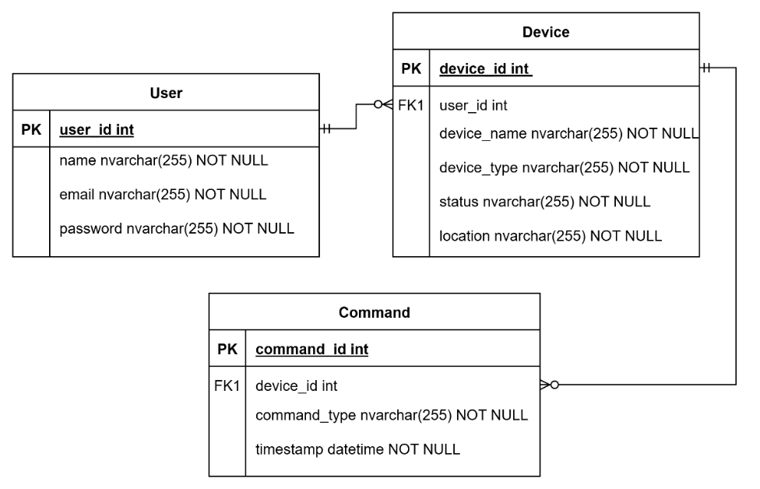

**Class Diagram:**

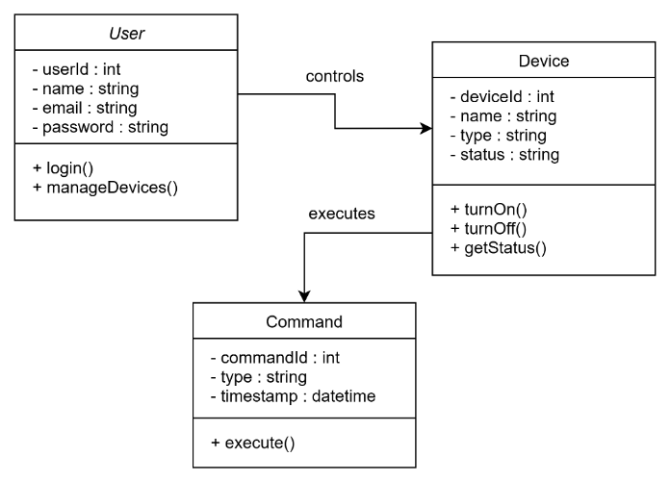

**Use-Case Diagram:**

**Sequence Diagram:**

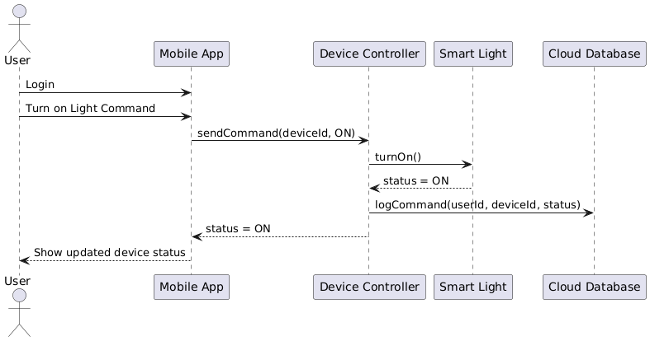

**Prototypes:**

**Low Fidelity Design:**

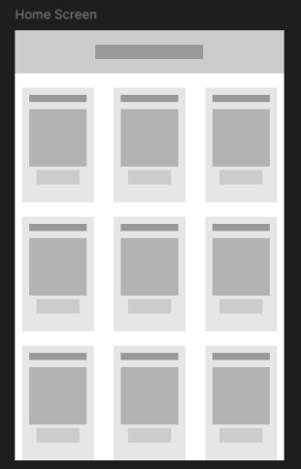**

[**https://www.figma.com/design/zbcnd4JJmx7fqfIoshIveK/Untitled?node-id=0-1&t=adxvdE4UShI0aOK6-1**](https://www.figma.com/design/zbcnd4JJmx7fqfIoshIveK/Untitled?node-id=0-1&t=adxvdE4UShI0aOK6-1)

**High Fidelity Design:**

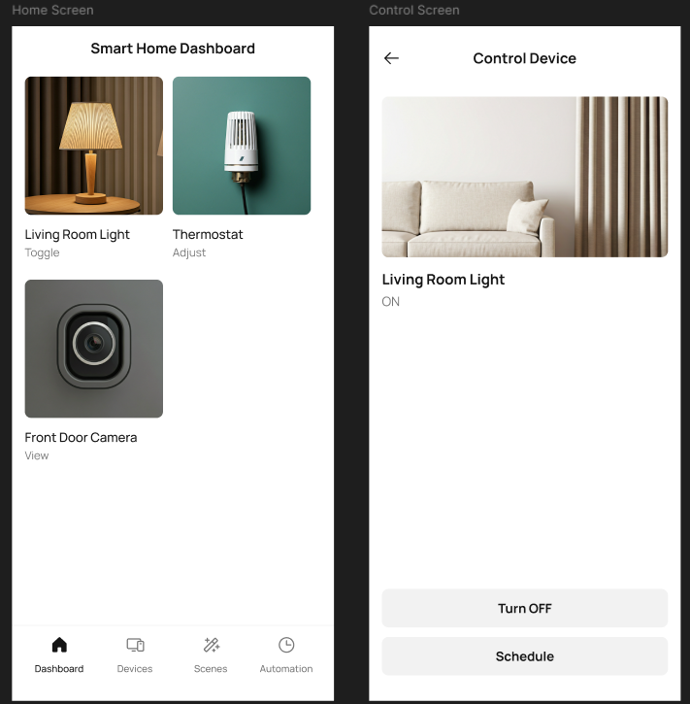

[**https://www.figma.com/design/ZdrsMt3TjHZpHrYwWhedPF/Untitled?node-id=0-1&t=70hwtefjxPikPEzr-1**](https://www.figma.com/design/ZdrsMt3TjHZpHrYwWhedPF/Untitled?node-id=0-1&t=70hwtefjxPikPEzr-1)